Client Authorization Code Lifespan:
អោយ code ដែលបានមកពី Keyloak Longer
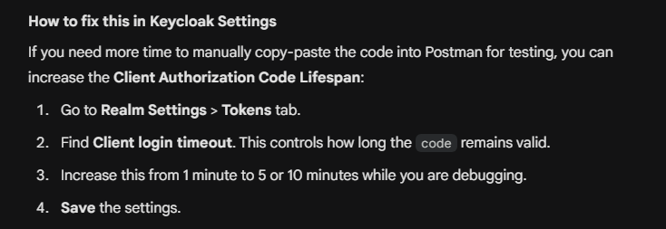

- Login as administrator

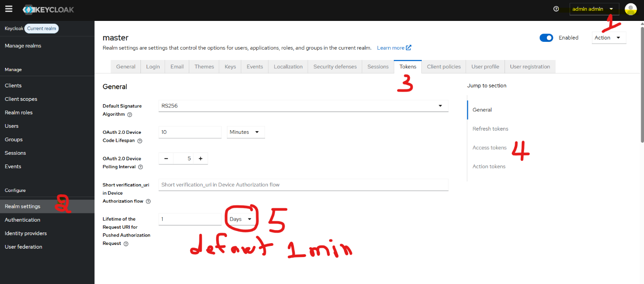

- Change Access Token time
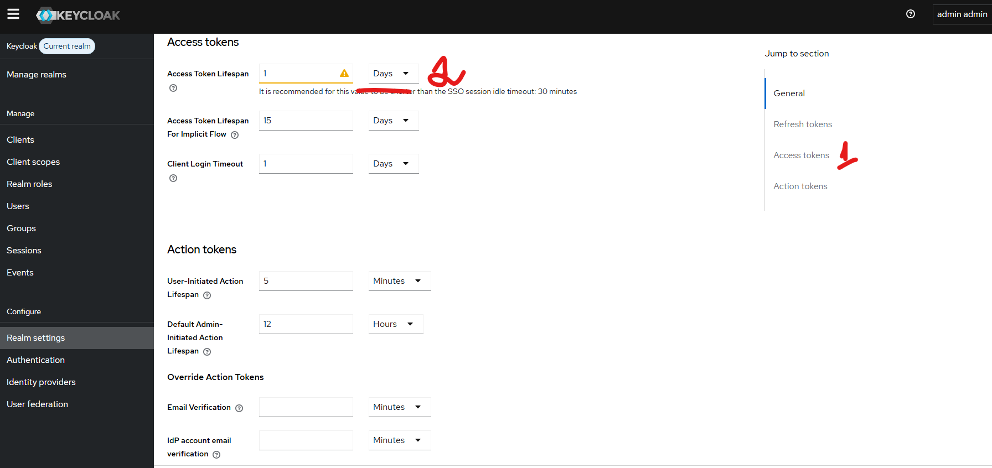

Note: Client Secrets in Keycloak do not actually expire.

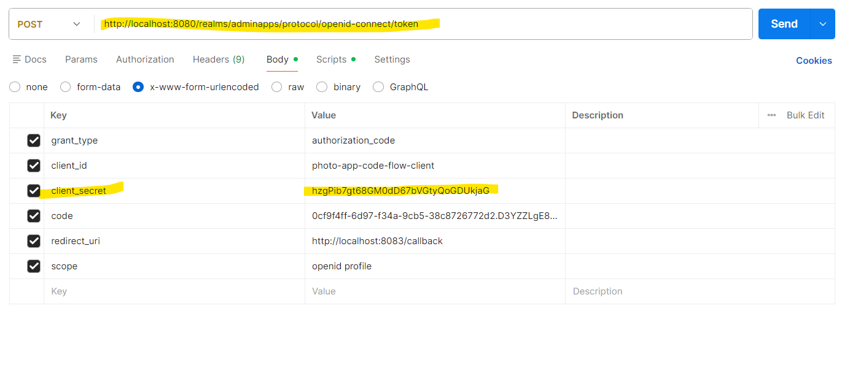

a Client Secret is a static credential. Once generated, it remains valid indefinitely until you manually click the Regenerate button shown in your image.

